CODE

from sklearn.metrics import accuracy_score

from sklearn.linear_model import LogisticRegression

from sklearn.model_selection import train_test_split

import matplotlib.pyplot as plt

import seaborn as sns

import pandas as pd

import numpy as np

import warnings

import sklearn

import sys

import os

#%%

DeprecationWarning('ignore')

warnings.filterwarnings('ignore')

os.chdir("D:/data_science/python/project/titanic")

#%%

os.getcwd()

#%%

os.listdir()

#%%

df=pd.read_csv('train.csv', na_filter=True)

#%%

df.shape

#%%

df.columns

#%%

df.info()

#%%

df.size

#%%

df.tail()

#%%

df.sample(3)

#%%

df.describe()

#%%

'''

.look at big picture

get the data

discover and visualize

preprocess the data, cleaning

choose machine learning model

hyper tune the model

deploy the model and check reguarly'''

#%% continous, discreate

sns.boxplot('Fare', data=df, orient='v')

#%%

sns.set_style('whitegrid')

sns.boxplot(x='Survived', y='Age', hue='Sex', data=df)

#%% corelation scatterplot: continous variable

sns.scatterplot(x='Age', y='Fare', data=df)

#%%

sns.distplot(df['Age'].dropna(), bins=8)

#%%

from scipy import stats

stats.kurtosis(df['Age'].dropna())

#%%

sns.barplot(x='Survived',y='Age', data=df)

#%%

df.isnull().sum()

#%% Preprocess the data

# Age

def fill_age(df):

df.Age.fillna()

#%%

df.describe()

#%%

train , test = train_test_split(df, test_size=0.2, random_state=12)

#%%

df.Age.mean()

#%% age

def fill_age(df):

df.Age.fillna(28, inplace=True)

return df

def fill_embarked(df):

df.Embarked.fillna('S', inplace=True)

return df

def fill_fare(df):

df.Fare.fillna(df['Fare'].mean(), inplace=True)

return df

def encode_gender(df):

from sklearn.preprocessing import LabelEncoder

label=LabelEncoder()

label.fit(df['Gender'], )

#%%

from sklearn.metrics import accuracy_score

from sklearn.linear_model import LogisticRegression

from sklearn.model_selection import train_test_split

import matplotlib.pyplot as plt

import seaborn as sns

import pandas as pd

import numpy as np

import warnings

import sys

import os

DeprecationWarning('ignore')

warnings.filterwarnings('ignore', message='Ignore mar')

os.chdir('D:/data_science/python/project/titanic')

#%%

os.getcwd()

#%%

os.listdir()

#%%

df=pd.read_csv('train.csv')

#%%

df.columns

#%%

df.head()

#%%

df.tail()

#%%

df.sample(5)

#%%

df.info()

#%%

def null_percent(df):

for column in df.columns:

percent=df[column].isnull().sum()/df[column].shape[0]

print(column, '=', (percent.round(3))*100)

null_percent(df)

#%%

df.Age.isnull().sum()

#%%

df.describe()

#%%

sns.set_style('whitegrid')

sns.boxplot(x='Age', data=df, orient='v')

#%%

sns.boxplot(x='Sex', y='Age',hue='Survived' ,orient='v',data=df)

plt.show()

#%%

sns.scatterplot(x='Age', y='Fare', data=df,hue='Sex' )

#%%

df.Sex.value_counts()

#%%

index=df[df.Fare<=0].index

free=df.iloc[index]

x=free.where(free.Pclass==1).index

df.iloc[x]

#%%

sns.distplot(df['Fare'].dropna(), bins=8, hist=True, kde=True, rug=True)

plt.show()

#%%

import scipy.stats as stats

stats.skew(df['Fare'].dropna())

#%%

sns.barplot(x='Embarked', y='Age', data=df)

#%%

def fill_age(df):

df.Age.fillna(28, inplace=True)

return df

def fill_Fare(df):

df.Fare.fillna(14, inplace=True)

return df

def fill_Embarked(df):

df.Embarked.fillna('S', inplace=True)

return df

def encode_label(df):

from sklearn.preprocessing import LabelEncoder

label=LabelEncoder()

df['Embarked']=label.fit_transform(df['Embarked'])

df['Sex']=label.fit_transform(df['Sex'])

df['Family']=df['SibSp']+ df['Parch']

return df

def drop_features(df):

df.drop(['Name','Cabin','Ticket', 'PassengerId'], axis=1,inplace=True)

return df

def encode_features(df):

df=fill_age(df)

df=fill_Fare(df)

df=fill_Embarked(df)

df=encode_label(df)

df=drop_features(df)

return df

df=encode_features(df)

#%%

df.head()

#%%

#%%

def x_matrix(df):

x=df.drop(['Survived'], axis=1)

y=df['Survived']

return x, y

train, test= train_test_split(df, test_size=0.2, random_state=2)

x_train, y_train=x_matrix(train)

x_test, y_test=x_matrix(test)

#%%

log_model=LogisticRegression()

log_model.fit(x_train, y_train)

prediction=log_model.predict_proba(x_test)

# score=accuracy_score(y_test, prediction)

# print(score)

#%%

prediction

#%%

from sklearn.tree import DecisionTreeClassifier

from sklearn.ensemble import RandomForestClassifier

dec_model=DecisionTreeClassifier()

dec_model.fit(x_train, y_train)

dec_prediction=dec_model.predict(x_test)

dec_score=accuracy_score(y_test, dec_prediction)

print(dec_score)

#%%

rand_model=RandomForestClassifier()

rand_model.fit(x_train, y_train)

rand_prediction=rand_model.predict(x_test)

rand_score=accuracy_score(y_test, rand_prediction)

print(rand_score)

OUTPUT:-

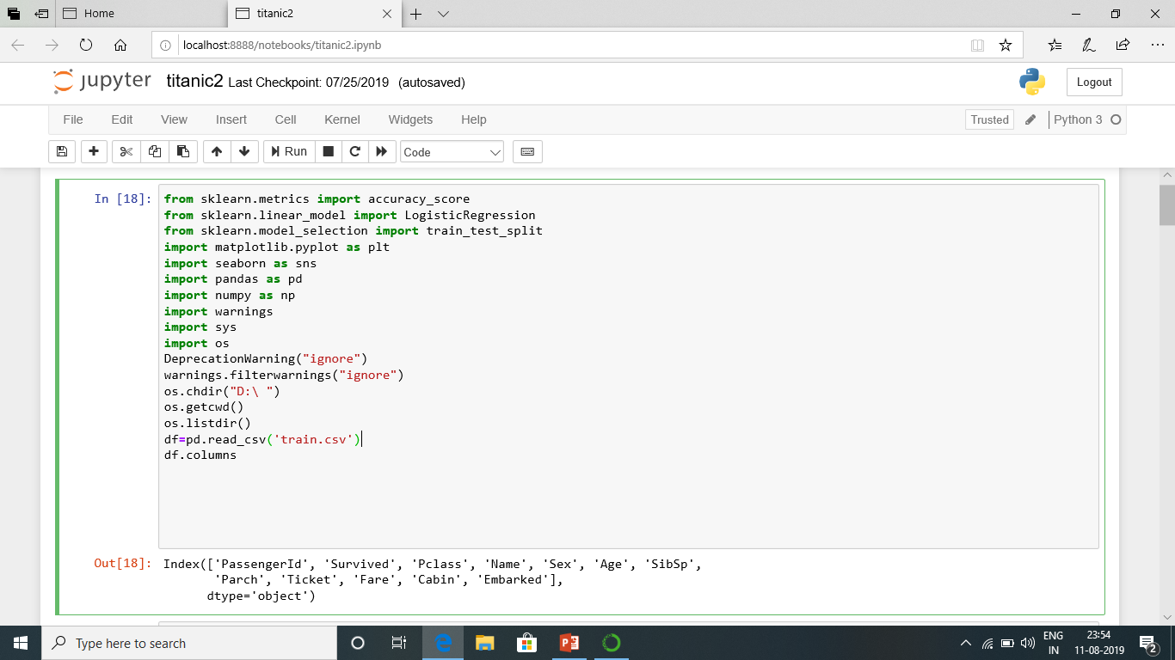

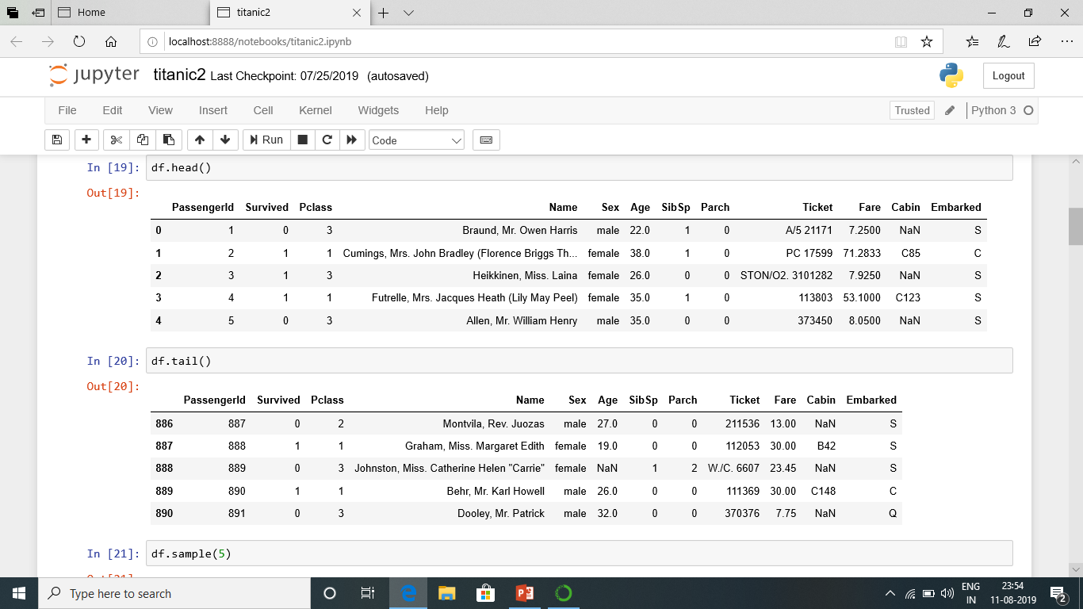

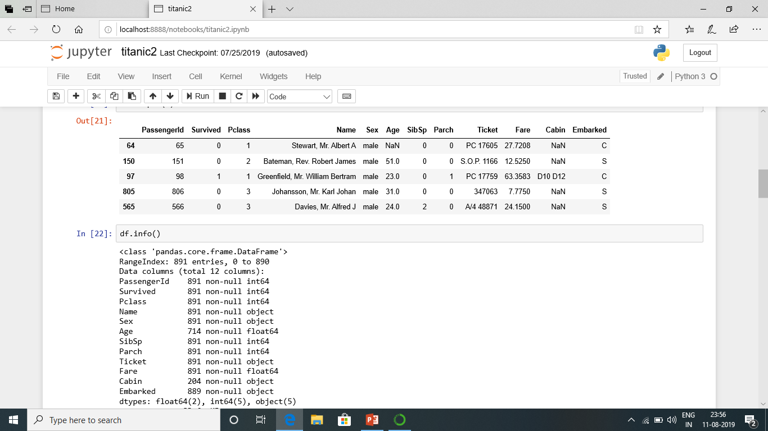

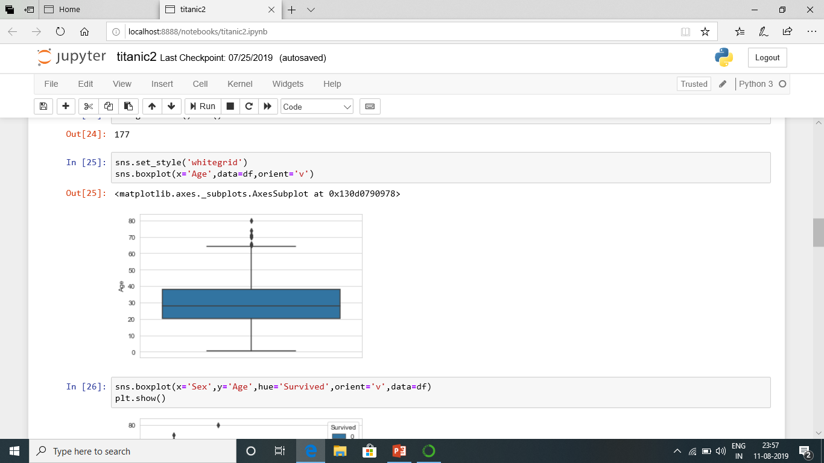

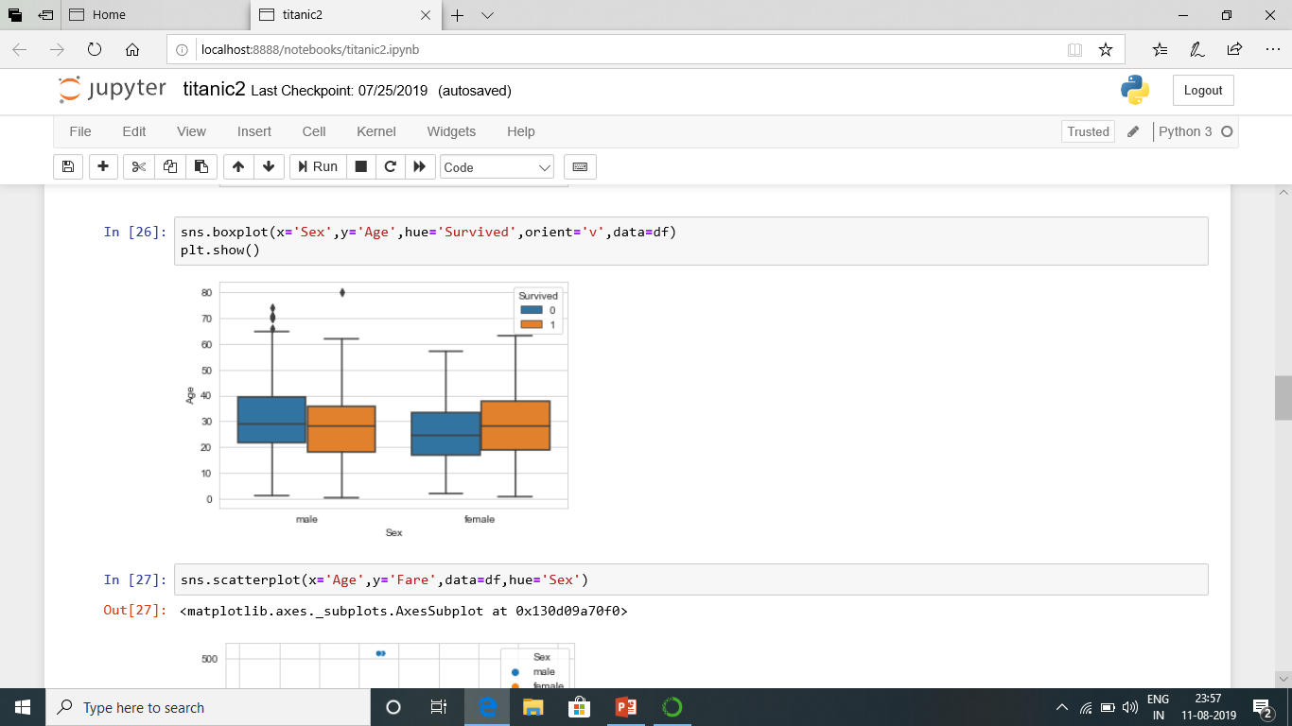

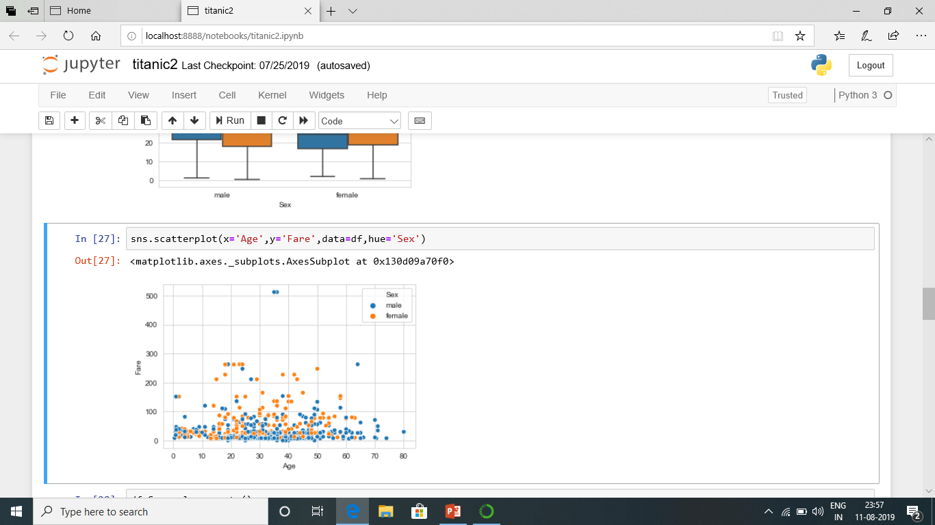

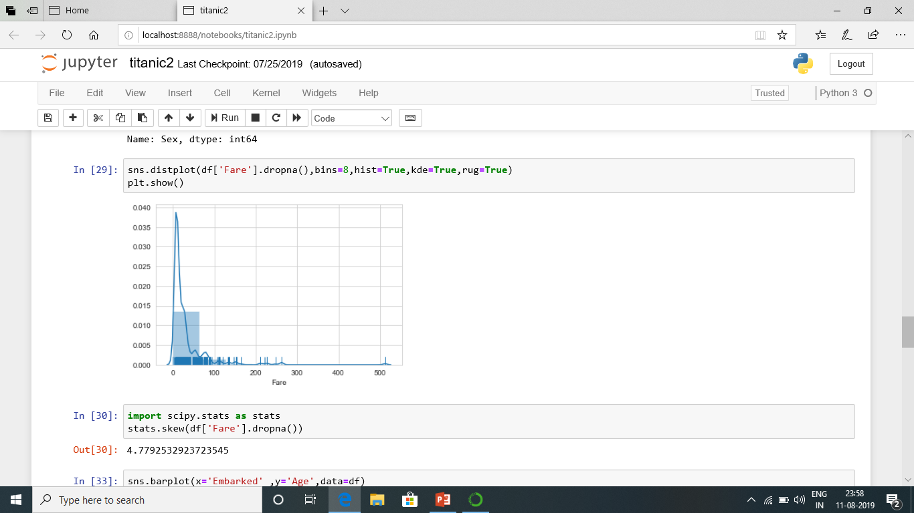

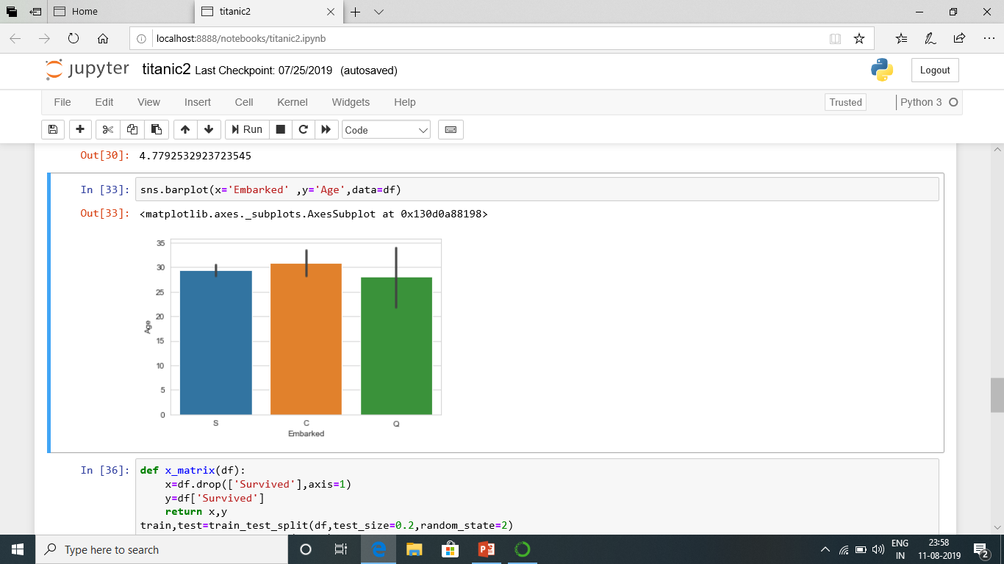

|  |  |  |  |  |  |  |  |  |  |  |  |
| --- | --- | --- | --- | --- | --- | --- | --- | --- | --- | --- | --- |
| Passenger Id | Survived | Pclass | Name | Sex | Age | SibSp | Parch | Ticket | Fare | Cabin | Embarked |
| 1 | 0 | 3 | Braund, | M | 22 | 1 | 0 | A/5 21171 | 7.25 |  | S |
| 2 | 1 | 1 | Cumings, | F | 38 | 1 | 0 | PC 17599 | 71.3 | C85 | C |
| 16 | 1 | 2 | Hewlett, Mrs. (Mary D Kingcome) | female | 55 | 0 | 0 | 248706 | 16 |  | S |
| 17 | 0 | 3 | Rice, Master. Eugene | male | 2 | 4 | 1 | 382652 | 29.1 |  | Q |
| 18 | 1 | 2 | Williams, Mr. Charles Eugene | male |  | 0 | 0 | 244373 | 13 |  | S |
| 19 | 0 | 3 | Vander Planke, Mrs. Julius (Emelia Maria Vandemoortele) | female | 31 | 1 | 0 | 345763 | 18 |  | S |
| 45 | 1 | 3 | Devaney, Miss. Margaret Delia | female | 19 | 0 | 0 | 330958 | 7.88 |  | Q |
| 46 | 0 | 3 | Rogers, Mr. William John | male |  | 0 | 0 | S.C./A.4. 23567 | 8.05 |  | S |
| 47 | 0 | 3 | Lennon, Mr. Denis | male |  | 1 | 0 | 370371 | 15.5 |  | Q |
| 48 | 1 | 3 | O'Driscoll, Miss. Bridget | female |  | 0 | 0 | 14311 | 7.75 |  | Q |
| 49 | 0 | 3 | Samaan, Mr. Youssef | male |  | 2 | 0 | 2662 | 21.7 |  | C |
| 50 | 0 | 3 | Arnold-Franchi, Mrs. Josef (Josefine Franchi) | female | 18 | 1 | 0 | 349237 | 17.8 |  | S |
| 51 | 0 | 3 | Panula, Master. Juha Niilo | male | 7 | 4 | 1 | 3101295 | 39.7 |  | S |
| 52 | 0 | 3 | Nosworthy, Mr. Richard Cater | male | 21 | 0 | 0 | A/4. 39886 | 7.8 |  | S |
| 53 | 1 | 1 | Harper, Mrs. Henry Sleeper (Myna Haxtun) | female | 49 | 1 | 0 | PC 17572 | 76.7 | D33 | C |
| 54 | 1 | 2 | Faunthorpe, Mrs. Lizzie (Elizabeth Anne Wilkinson) | female | 29 | 1 | 0 | 2926 | 26 |  | S |
| 55 | 0 | 1 | Ostby, Mr. Engelhart Cornelius | male | 65 | 0 | 1 | 113509 | 62 | B30 | C |
| 56 | 1 | 1 | Woolner, Mr. Hugh | male |  | 0 | 0 | 19947 | 35.5 | C52 | S |
| 57 | 1 | 2 | Rugg, Miss. Emily | female | 21 | 0 | 0 | C.A. 31026 | 10.5 |  | S |
| 58 | 0 | 3 | Novel, Mr. Mansouer | male | 29 | 0 | 0 | 2697 | 7.23 |  | C |
| 59 | 1 | 2 | West, Miss. Constance Mirium | female | 5 | 1 | 2 | C.A. 34651 | 27.8 |  | S |
| 60 | 0 | 3 | Goodwin, Master. William Frederick | male | 11 | 5 | 2 | CA 2144 | 46.9 |  | S |
| 61 | 0 | 3 | Sirayanian, Mr. Orsen | male | 22 | 0 | 0 | 2669 | 7.23 |  | C |
| 62 | 1 | 1 | Icard, Miss. Amelie | female | 38 | 0 | 0 | 113572 | 80 | B28 |  |
| 63 | 0 | 1 | Harris, Mr. Henry Birkhardt | male | 45 | 1 | 0 | 36973 | 83.5 | C83 | S |
| 64 | 0 | 3 | Skoog, Master. Harald | male | 4 | 3 | 2 | 347088 | 27.9 |  | S |
| 65 | 0 | 1 | Stewart, Mr. Albert A | male |  | 0 | 0 | PC 17605 | 27.7 |  | C |
| 66 | 1 | 3 | Moubarek, Master. Gerios | male |  | 1 | 1 | 2661 | 15.2 |  | C |
| 67 | 1 | 2 | Nye, Mrs. (Elizabeth Ramell) | female | 29 | 0 | 0 | C.A. 29395 | 10.5 | F33 | S |
| 68 | 0 | 3 | Crease, Mr. Ernest James | male | 19 | 0 | 0 | S.P. 3464 | 8.16 |  | S |
| 69 | 1 | 3 | Andersson, Miss. Erna Alexandra | female | 17 | 4 | 2 | 3101281 | 7.93 |  | S |
| 70 | 0 | 3 | Kink, Mr. Vincenz | male | 26 | 2 | 0 | 315151 | 8.66 |  | S |
| 71 | 0 | 2 | Jenkin, Mr. Stephen Curnow | male | 32 | 0 | 0 | C.A. 33111 | 10.5 |  | S |
| 72 | 0 | 3 | Goodwin, Miss. Lillian Amy | female | 16 | 5 | 2 | CA 2144 | 46.9 |  | S |
| 73 | 0 | 2 | Hood, Mr. Ambrose Jr | male | 21 | 0 | 0 | S.O.C. 14879 | 73.5 |  | S |
| 74 | 0 | 3 | Chronopoulos, Mr. Apostolos | male | 26 | 1 | 0 | 2680 | 14.5 |  | C |
| 101 | 0 | 3 | Petranec, Miss. Matilda | female | 28 | 0 | 0 | 349245 | 7.9 |  | S |
| 102 | 0 | 3 | Petroff, Mr. Pastcho ("Pentcho") | male |  | 0 | 0 | 349215 | 7.9 |  | S |
| 103 | 0 | 1 | White, Mr. Richard Frasar | male | 21 | 0 | 1 | 35281 | 77.3 | D26 | S |
| 104 | 0 | 3 | Johansson, Mr. Gustaf Joel | male | 33 | 0 | 0 | 7540 | 8.65 |  | S |
| 105 | 0 | 3 | Gustafsson, Mr. Anders Vilhelm | male | 37 | 2 | 0 | 3101276 | 7.93 |  | S |
| 106 | 0 | 3 | Mionoff, Mr. Stoytcho | male | 28 | 0 | 0 | 349207 | 7.9 |  | S |
| 107 | 1 | 3 | Salkjelsvik, Miss. Anna Kristine | female | 21 | 0 | 0 | 343120 | 7.65 |  | S |
| 108 | 1 | 3 | Moss, Mr. Albert Johan | male |  | 0 | 0 | 312991 | 7.78 |  | S |
| 109 | 0 | 3 | Rekic, Mr. Tido | male | 38 | 0 | 0 | 349249 | 7.9 |  | S |
| 110 | 1 | 3 | Moran, Miss. Bertha | female |  | 1 | 0 | 371110 | 24.2 |  | Q |
| 111 | 0 | 1 | Porter, Mr. Walter Chamberlain | male | 47 | 0 | 0 | 110465 | 52 | C110 | S |
| 112 | 0 | 3 | Zabour, Miss. Hileni | female | 15 | 1 | 0 | 2665 | 14.5 |  | C |
| 113 | 0 | 3 | Barton, Mr. David John | male | 22 | 0 | 0 | 324669 | 8.05 |  | S |
| 114 | 0 | 3 | Jussila, Miss. Katriina | female | 20 | 1 | 0 | 4136 | 9.83 |  | S |
| 115 | 0 | 3 | Attalah, Miss. Malake | female | 17 | 0 | 0 | 2627 | 14.5 |  | C |
| 116 | 0 | 3 | Pekoniemi, Mr. Edvard | male | 21 | 0 | 0 | STON/O 2. 3101294 | 7.93 |  | S |
| 117 | 0 | 3 | Connors, Mr. Patrick | male | 71 | 0 | 0 | 370369 | 7.75 |  | Q |
| 118 | 0 | 2 | Turpin, Mr. William John Robert | male | 29 | 1 | 0 | 11668 | 21 |  | S |
| 119 | 0 | 1 | Baxter, Mr. Quigg Edmond | male | 24 | 0 | 1 | PC 17558 | 248 | B58 B60 | C |
| 120 | 0 | 3 | Andersson, Miss. Ellis Anna Maria | female | 2 | 4 | 2 | 347082 | 31.3 |  | S |
| 121 | 0 | 2 | Hickman, Mr. Stanley George | male | 21 | 2 | 0 | S.O.C. 14879 | 73.5 |  | S |
| 122 | 0 | 3 | Moore, Mr. Leonard Charles | male |  | 0 | 0 | A4. 54510 | 8.05 |  | S |
| 123 | 0 | 2 | Nasser, Mr. Nicholas | male | 33 | 1 | 0 | 237736 | 30.1 |  | C |
| 124 | 1 | 2 | Webber, Miss. Susan | female | 33 | 0 | 0 | 27267 | 13 | E101 | S |
| 125 | 0 | 1 | White, Mr. Percival Wayland | male | 54 | 0 | 1 | 35281 | 77.3 | D26 | S |
| 126 | 1 | 3 | Nicola-Yarred, Master. Elias | male | 12 | 1 | 0 | 2651 | 11.2 |  | C |
| 127 | 0 | 3 | McMahon, Mr. Martin | male |  | 0 | 0 | 370372 | 7.75 |  | Q |
| 128 | 1 | 3 | Madsen, Mr. Fridtjof Arne | male | 24 | 0 | 0 | C 17369 | 7.14 |  | S |
| 129 | 1 | 3 | Peter, Miss. Anna | female |  | 1 | 1 | 2668 | 22.4 | F E69 | C |
| 130 | 0 | 3 | Ekstrom, Mr. Johan | male | 45 | 0 | 0 | 347061 | 6.98 |  | S |
| 131 | 0 | 3 | Drazenoic, Mr. Jozef | male | 33 | 0 | 0 | 349241 | 7.9 |  | C |
| 132 | 0 | 3 | Coelho, Mr. Domingos Fernandeo | male | 20 | 0 | 0 | SOTON/O.Q. 3101307 | 7.05 |  | S |
| 226 | 0 | 3 | Berglund, Mr. Karl Ivar Sven | male | 22 | 0 | 0 | PP 4348 | 9.35 |  | S |
| 227 | 1 | 2 | Mellors, Mr. William John | male | 19 | 0 | 0 | SW/PP 751 | 10.5 |  | S |
| 228 | 0 | 3 | Lovell, Mr. John Hall ("Henry") | male | 21 | 0 | 0 | A/5 21173 | 7.25 |  | S |
| 229 | 0 | 2 | Fahlstrom, Mr. Arne Jonas | male | 18 | 0 | 0 | 236171 | 13 |  | S |
| 230 | 0 | 3 | Lefebre, Miss. Mathilde | female |  | 3 | 1 | 4133 | 25.5 |  | S |
| 231 | 1 | 1 | Harris, Mrs. Henry Birkhardt (Irene Wallach) | female | 35 | 1 | 0 | 36973 | 83.5 | C83 | S |
| 232 | 0 | 3 | Larsson, Mr. Bengt Edvin | male | 29 | 0 | 0 | 347067 | 7.78 |  | S |
| 233 | 0 | 2 | Sjostedt, Mr. Ernst Adolf | male | 59 | 0 | 0 | 237442 | 13.5 |  | S |
| 234 | 1 | 3 | Asplund, Miss. Lillian Gertrud | female | 5 | 4 | 2 | 347077 | 31.4 |  | S |
| 235 | 0 | 2 | Leyson, Mr. Robert William Norman | male | 24 | 0 | 0 | C.A. 29566 | 10.5 |  | S |
| 236 | 0 | 3 | Harknett, Miss. Alice Phoebe | female |  | 0 | 0 | W./C. 6609 | 7.55 |  | S |
| 237 | 0 | 2 | Hold, Mr. Stephen | male | 44 | 1 | 0 | 26707 | 26 |  | S |
| 238 | 1 | 2 | Collyer, Miss. Marjorie "Lottie" | female | 8 | 0 | 2 | C.A. 31921 | 26.3 |  | S |
| 239 | 0 | 2 | Pengelly, Mr. Frederick William | male | 19 | 0 | 0 | 28665 | 10.5 |  | S |
| 240 | 0 | 2 | Hunt, Mr. George Henry | male | 33 | 0 | 0 | SCO/W 1585 | 12.3 |  | S |
| 241 | 0 | 3 | Zabour, Miss. Thamine | female |  | 1 | 0 | 2665 | 14.5 |  | C |
| 242 | 1 | 3 | Murphy, Miss. Katherine "Kate" | female |  | 1 | 0 | 367230 | 15.5 |  | Q |
| 243 | 0 | 2 | Coleridge, Mr. Reginald Charles | male | 29 | 0 | 0 | W./C. 14263 | 10.5 |  | S |
| 244 | 0 | 3 | Maenpaa, Mr. Matti Alexanteri | male | 22 | 0 | 0 | STON/O 2. 3101275 | 7.13 |  | S |
| 245 | 0 | 3 | Attalah, Mr. Sleiman | male | 30 | 0 | 0 | 2694 | 7.23 |  | C |
| 246 | 0 | 1 | Minahan, Dr. William Edward | male | 44 | 2 | 0 | 19928 | 90 | C78 | Q |
| 247 | 0 | 3 | Lindahl, Miss. Agda Thorilda Viktoria | female | 25 | 0 | 0 | 347071 | 7.78 |  | S |
| 248 | 1 | 2 | Hamalainen, Mrs. William (Anna) | female | 24 | 0 | 2 | 250649 | 14.5 |  | S |
| 249 | 1 | 1 | Beckwith, Mr. Richard Leonard | male | 37 | 1 | 1 | 11751 | 52.6 | D35 | S |
| 250 | 0 | 2 | Carter, Rev. Ernest Courtenay | male | 54 | 1 | 0 | 244252 | 26 |  | S |
| 251 | 0 | 3 | Reed, Mr. James George | male |  | 0 | 0 | 362316 | 7.25 |  | S |
| 252 | 0 | 3 | Strom, Mrs. Wilhelm (Elna Matilda Persson) | female | 29 | 1 | 1 | 347054 | 10.5 | G6 | S |
| 253 | 0 | 1 | Stead, Mr. William Thomas | male | 62 | 0 | 0 | 113514 | 26.6 | C87 | S |
| 254 | 0 | 3 | Lobb, Mr. William Arthur | male | 30 | 1 | 0 | A/5. 3336 | 16.1 |  | S |
| 255 | 0 | 3 | Rosblom, Mrs. Viktor (Helena Wilhelmina) | female | 41 | 0 | 2 | 370129 | 20.2 |  | S |
| 256 | 1 | 3 | Touma, Mrs. Darwis (Hanne Youssef Razi) | female | 29 | 0 | 2 | 2650 | 15.2 |  | C |
| 257 | 1 | 1 | Thorne, Mrs. Gertrude Maybelle | female |  | 0 | 0 | PC 17585 | 79.2 |  | C |
| 258 | 1 | 1 | Cherry, Miss. Gladys | female | 30 | 0 | 0 | 110152 | 86.5 | B77 | S |
| 259 | 1 | 1 | Ward, Miss. Anna | female | 35 | 0 | 0 | PC 17755 | 512 |  | C |
| 260 | 1 | 2 | Parrish, Mrs. (Lutie Davis) | female | 50 | 0 | 1 | 230433 | 26 |  | S |
| 261 | 0 | 3 | Smith, Mr. Thomas | male |  | 0 | 0 | 384461 | 7.75 |  | Q |
| 262 | 1 | 3 | Asplund, Master. Edvin Rojj Felix | male | 3 | 4 | 2 | 347077 | 31.4 |  | S |
| 263 | 0 | 1 | Taussig, Mr. Emil | male | 52 | 1 | 1 | 110413 | 79.7 | E67 | S |
| 264 | 0 | 1 | Harrison, Mr. William | male | 40 | 0 | 0 | 112059 | 0 | B94 | S |
| 265 | 0 | 3 | Henry, Miss. Delia | female |  | 0 | 0 | 382649 | 7.75 |  | Q |
| 266 | 0 | 2 | Reeves, Mr. David | male | 36 | 0 | 0 | C.A. 17248 | 10.5 |  | S |
| 267 | 0 | 3 | Panula, Mr. Ernesti Arvid | male | 16 | 4 | 1 | 3101295 | 39.7 |  | S |
| 268 | 1 | 3 | Persson, Mr. Ernst Ulrik | male | 25 | 1 | 0 | 347083 | 7.78 |  | S |
| 269 | 1 | 1 | Graham, Mrs. William Thompson (Edith Junkins) | female | 58 | 0 | 1 | PC 17582 | 153 | C125 | S |
| 270 | 1 | 1 | Bissette, Miss. Amelia | female | 35 | 0 | 0 | PC 17760 | 136 | C99 | S |
| 271 | 0 | 1 | Cairns, Mr. Alexander | male |  | 0 | 0 | 113798 | 31 |  | S |
| 272 | 1 | 3 | Tornquist, Mr. William Henry | male | 25 | 0 | 0 | LINE | 0 |  | S |
| 273 | 1 | 2 | Mellinger, Mrs. (Elizabeth Anne Maidment) | female | 41 | 0 | 1 | 250644 | 19.5 |  | S |
| 274 | 0 | 1 | Natsch, Mr. Charles H | male | 37 | 0 | 1 | PC 17596 | 29.7 | C118 | C |
| 275 | 1 | 3 | Healy, Miss. Hanora "Nora" | female |  | 0 | 0 | 370375 | 7.75 |  | Q |
| 276 | 1 | 1 | Andrews, Miss. Kornelia Theodosia | female | 63 | 1 | 0 | 13502 | 78 | D7 | S |
| 277 | 0 | 3 | Lindblom, Miss. Augusta Charlotta | female | 45 | 0 | 0 | 347073 | 7.75 |  | S |
| 278 | 0 | 2 | Parkes, Mr. Francis "Frank" | male |  | 0 | 0 | 239853 | 0 |  | S |
| 279 | 0 | 3 | Rice, Master. Eric | male | 7 | 4 | 1 | 382652 | 29.1 |  | Q |
| 280 | 1 | 3 | Abbott, Mrs. Stanton (Rosa Hunt) | female | 35 | 1 | 1 | C.A. 2673 | 20.3 |  | S |
| 281 | 0 | 3 | Duane, Mr. Frank | male | 65 | 0 | 0 | 336439 | 7.75 |  | Q |
| 282 | 0 | 3 | Olsson, Mr. Nils Johan Goransson | male | 28 | 0 | 0 | 347464 | 7.85 |  | S |
| 283 | 0 | 3 | de Pelsmaeker, Mr. Alfons | male | 16 | 0 | 0 | 345778 | 9.5 |  | S |
| 284 | 1 | 3 | Dorking, Mr. Edward Arthur | male | 19 | 0 | 0 | A/5. 10482 | 8.05 |  | S |
| 285 | 0 | 1 | Smith, Mr. Richard William | male |  | 0 | 0 | 113056 | 26 | A19 | S |
| 286 | 0 | 3 | Stankovic, Mr. Ivan | male | 33 | 0 | 0 | 349239 | 8.66 |  | C |
| 287 | 1 | 3 | de Mulder, Mr. Theodore | male | 30 | 0 | 0 | 345774 | 9.5 |  | S |
| 288 | 0 | 3 | Naidenoff, Mr. Penko | male | 22 | 0 | 0 | 349206 | 7.9 |  | S |
| 289 | 1 | 2 | Hosono, Mr. Masabumi | male | 42 | 0 | 0 | 237798 | 13 |  | S |
| 290 | 1 | 3 | Connolly, Miss. Kate | female | 22 | 0 | 0 | 370373 | 7.75 |  | Q |
| 291 | 1 | 1 | Barber, Miss. Ellen "Nellie" | female | 26 | 0 | 0 | 19877 | 78.9 |  | S |
| 292 | 1 | 1 | Bishop, Mrs. Dickinson H (Helen Walton) | female | 19 | 1 | 0 | 11967 | 91.1 | B49 | C |
| 293 | 0 | 2 | Levy, Mr. Rene Jacques | male | 36 | 0 | 0 | SC/Paris 2163 | 12.9 | D | C |
| 294 | 0 | 3 | Haas, Miss. Aloisia | female | 24 | 0 | 0 | 349236 | 8.85 |  | S |
| 295 | 0 | 3 | Mineff, Mr. Ivan | male | 24 | 0 | 0 | 349233 | 7.9 |  | S |
| 296 | 0 | 1 | Lewy, Mr. Ervin G | male |  | 0 | 0 | PC 17612 | 27.7 |  | C |
| 297 | 0 | 3 | Hanna, Mr. Mansour | male | 24 | 0 | 0 | 2693 | 7.23 |  | C |
| 298 | 0 | 1 | Allison, Miss. Helen Loraine | female | 2 | 1 | 2 | 113781 | 152 | C22 C26 | S |
| 299 | 1 | 1 | Saalfeld, Mr. Adolphe | male |  | 0 | 0 | 19988 | 30.5 | C106 | S |
| 300 | 1 | 1 | Baxter, Mrs. James (Helene DeLaudeniere Chaput) | female | 50 | 0 | 1 | PC 17558 | 248 | B58 B60 | C |
| 301 | 1 | 3 | Kelly, Miss. Anna Katherine "Annie Kate" | female |  | 0 | 0 | 9234 | 7.75 |  | Q |
| 302 | 1 | 3 | McCoy, Mr. Bernard | male |  | 2 | 0 | 367226 | 23.3 |  | Q |
| 303 | 0 | 3 | Johnson, Mr. William Cahoone Jr | male | 19 | 0 | 0 | LINE | 0 |  | S |
| 304 | 1 | 2 | Keane, Miss. Nora A | female |  | 0 | 0 | 226593 | 12.4 | E101 | Q |
| 305 | 0 | 3 | Williams, Mr. Howard Hugh "Harry" | male |  | 0 | 0 | A/5 2466 | 8.05 |  | S |
| 306 | 1 | 1 | Allison, Master. Hudson Trevor | male | 0.9 | 1 | 2 | 113781 | 152 | C22 C26 | S |
| 307 | 1 | 1 | Fleming, Miss. Margaret | female |  | 0 | 0 | 17421 | 111 |  | C |
| 308 | 1 | 1 | Penasco y Castellana, Mrs. Victor de Satode (Maria Josefa Perez de Soto y Vallejo) | female | 17 | 1 | 0 | PC 17758 | 109 | C65 | C |
| 309 | 0 | 2 | Abelson, Mr. Samuel | male | 30 | 1 | 0 | P/PP 3381 | 24 |  | C |
| 310 | 1 | 1 | Francatelli, Miss. Laura Mabel | female | 30 | 0 | 0 | PC 17485 | 56.9 | E36 | C |
| 311 | 1 | 1 | Hays, Miss. Margaret Bechstein | female | 24 | 0 | 0 | 11767 | 83.2 | C54 | C |
| 312 | 1 | 1 | Ryerson, Miss. Emily Borie | female | 18 | 2 | 2 | PC 17608 | 262 | B57 B59 B63 B66 | C |
| 313 | 0 | 2 | Lahtinen, Mrs. William (Anna Sylfven) | female | 26 | 1 | 1 | 250651 | 26 |  | S |
| 314 | 0 | 3 | Hendekovic, Mr. Ignjac | male | 28 | 0 | 0 | 349243 | 7.9 |  | S |
| 315 | 0 | 2 | Hart, Mr. Benjamin | male | 43 | 1 | 1 | F.C.C. 13529 | 26.3 |  | S |
| 316 | 1 | 3 | Nilsson, Miss. Helmina Josefina | female | 26 | 0 | 0 | 347470 | 7.85 |  | S |
| 317 | 1 | 2 | Kantor, Mrs. Sinai (Miriam Sternin) | female | 24 | 1 | 0 | 244367 | 26 |  | S |
| 318 | 0 | 2 | Moraweck, Dr. Ernest | male | 54 | 0 | 0 | 29011 | 14 |  | S |
| 319 | 1 | 1 | Wick, Miss. Mary Natalie | female | 31 | 0 | 2 | 36928 | 165 | C7 | S |
| 320 | 1 | 1 | Spedden, Mrs. Frederic Oakley (Margaretta Corning Stone) | female | 40 | 1 | 1 | 16966 | 135 | E34 | C |
| 321 | 0 | 3 | Dennis, Mr. Samuel | male | 22 | 0 | 0 | A/5 21172 | 7.25 |  | S |
| 322 | 0 | 3 | Danoff, Mr. Yoto | male | 27 | 0 | 0 | 349219 | 7.9 |  | S |
| 323 | 1 | 2 | Slayter, Miss. Hilda Mary | female | 30 | 0 | 0 | 234818 | 12.4 |  | Q |
| 324 | 1 | 2 | Caldwell, Mrs. Albert Francis (Sylvia Mae Harbaugh) | female | 22 | 1 | 1 | 248738 | 29 |  | S |
| 325 | 0 | 3 | Sage, Mr. George John Jr | male |  | 8 | 2 | CA. 2343 | 69.6 |  | S |
| 326 | 1 | 1 | Young, Miss. Marie Grice | female | 36 | 0 | 0 | PC 17760 | 136 | C32 | C |
| 327 | 0 | 3 | Nysveen, Mr. Johan Hansen | male | 61 | 0 | 0 | 345364 | 6.24 |  | S |
| 328 | 1 | 2 | Ball, Mrs. (Ada E Hall) | female | 36 | 0 | 0 | 28551 | 13 | D | S |
| 329 | 1 | 3 | Goldsmith, Mrs. Frank John (Emily Alice Brown) | female | 31 | 1 | 1 | 363291 | 20.5 |  | S |
| 330 | 1 | 1 | Hippach, Miss. Jean Gertrude | female | 16 | 0 | 1 | 111361 | 58 | B18 | C |
| 331 | 1 | 3 | McCoy, Miss. Agnes | female |  | 2 | 0 | 367226 | 23.3 |  | Q |
| 332 | 0 | 1 | Partner, Mr. Austen | male | 46 | 0 | 0 | 113043 | 28.5 | C124 | S |
| 333 | 0 | 1 | Graham, Mr. George Edward | male | 38 | 0 | 1 | PC 17582 | 153 | C91 | S |
| 334 | 0 | 3 | Vander Planke, Mr. Leo Edmondus | male | 16 | 2 | 0 | 345764 | 18 |  | S |
| 335 | 1 | 1 | Frauenthal, Mrs. Henry William (Clara Heinsheimer) | female |  | 1 | 0 | PC 17611 | 134 |  | S |
| 336 | 0 | 3 | Denkoff, Mr. Mitto | male |  | 0 | 0 | 349225 | 7.9 |  | S |
| 337 | 0 | 1 | Pears, Mr. Thomas Clinton | male | 29 | 1 | 0 | 113776 | 66.6 | C2 | S |
| 338 | 1 | 1 | Burns, Miss. Elizabeth Margaret | female | 41 | 0 | 0 | 16966 | 135 | E40 | C |
| 339 | 1 | 3 | Dahl, Mr. Karl Edwart | male | 45 | 0 | 0 | 7598 | 8.05 |  | S |
| 340 | 0 | 1 | Blackwell, Mr. Stephen Weart | male | 45 | 0 | 0 | 113784 | 35.5 | T | S |
| 341 | 1 | 2 | Navratil, Master. Edmond Roger | male | 2 | 1 | 1 | 230080 | 26 | F2 | S |
| 342 | 1 | 1 | Fortune, Miss. Alice Elizabeth | female | 24 | 3 | 2 | 19950 | 263 | C23 C25 C27 | S |
| 343 | 0 | 2 | Collander, Mr. Erik Gustaf | male | 28 | 0 | 0 | 248740 | 13 |  | S |
| 344 | 0 | 2 | Sedgwick, Mr. Charles Frederick Waddington | male | 25 | 0 | 0 | 244361 | 13 |  | S |
| 345 | 0 | 2 | Fox, Mr. Stanley Hubert | male | 36 | 0 | 0 | 229236 | 13 |  | S |
| 346 | 1 | 2 | Brown, Miss. Amelia "Mildred" | female | 24 | 0 | 0 | 248733 | 13 | F33 | S |
| 347 | 1 | 2 | Smith, Miss. Marion Elsie | female | 40 | 0 | 0 | 31418 | 13 |  | S |
| 348 | 1 | 3 | Davison, Mrs. Thomas Henry (Mary E Finck) | female |  | 1 | 0 | 386525 | 16.1 |  | S |
| 349 | 1 | 3 | Coutts, Master. William Loch "William" | male | 3 | 1 | 1 | C.A. 37671 | 15.9 |  | S |
| 350 | 0 | 3 | Dimic, Mr. Jovan | male | 42 | 0 | 0 | 315088 | 8.66 |  | S |
| 351 | 0 | 3 | Odahl, Mr. Nils Martin | male | 23 | 0 | 0 | 7267 | 9.23 |  | S |
| 352 | 0 | 1 | Williams-Lambert, Mr. Fletcher Fellows | male |  | 0 | 0 | 113510 | 35 | C128 | S |
| 353 | 0 | 3 | Elias, Mr. Tannous | male | 15 | 1 | 1 | 2695 | 7.23 |  | C |
| 354 | 0 | 3 | Arnold-Franchi, Mr. Josef | male | 25 | 1 | 0 | 349237 | 17.8 |  | S |
| 355 | 0 | 3 | Yousif, Mr. Wazli | male |  | 0 | 0 | 2647 | 7.23 |  | C |
| 356 | 0 | 3 | Vanden Steen, Mr. Leo Peter | male | 28 | 0 | 0 | 345783 | 9.5 |  | S |
| 357 | 1 | 1 | Bowerman, Miss. Elsie Edith | female | 22 | 0 | 1 | 113505 | 55 | E33 | S |
| 358 | 0 | 2 | Funk, Miss. Annie Clemmer | female | 38 | 0 | 0 | 237671 | 13 |  | S |
| 359 | 1 | 3 | McGovern, Miss. Mary | female |  | 0 | 0 | 330931 | 7.88 |  | Q |
| 360 | 1 | 3 | Mockler, Miss. Helen Mary "Ellie" | female |  | 0 | 0 | 330980 | 7.88 |  | Q |
| 361 | 0 | 3 | Skoog, Mr. Wilhelm | male | 40 | 1 | 4 | 347088 | 27.9 |  | S |
| 362 | 0 | 2 | del Carlo, Mr. Sebastiano | male | 29 | 1 | 0 | SC/PARIS 2167 | 27.7 |  | C |
| 363 | 0 | 3 | Barbara, Mrs. (Catherine David) | female | 45 | 0 | 1 | 2691 | 14.5 |  | C |
| 364 | 0 | 3 | Asim, Mr. Adola | male | 35 | 0 | 0 | SOTON/O.Q. 3101310 | 7.05 |  | S |
| 365 | 0 | 3 | O'Brien, Mr. Thomas | male |  | 1 | 0 | 370365 | 15.5 |  | Q |
| 366 | 0 | 3 | Adahl, Mr. Mauritz Nils Martin | male | 30 | 0 | 0 | C 7076 | 7.25 |  | S |
| 367 | 1 | 1 | Warren, Mrs. Frank Manley (Anna Sophia Atkinson) | female | 60 | 1 | 0 | 110813 | 75.3 | D37 | C |
| 368 | 1 | 3 | Moussa, Mrs. (Mantoura Boulos) | female |  | 0 | 0 | 2626 | 7.23 |  | C |
| 369 | 1 | 3 | Jermyn, Miss. Annie | female |  | 0 | 0 | 14313 | 7.75 |  | Q |
| 370 | 1 | 1 | Aubart, Mme. Leontine Pauline | female | 24 | 0 | 0 | PC 17477 | 69.3 | B35 | C |
| 371 | 1 | 1 | Harder, Mr. George Achilles | male | 25 | 1 | 0 | 11765 | 55.4 | E50 | C |
| 372 | 0 | 3 | Wiklund, Mr. Jakob Alfred | male | 18 | 1 | 0 | 3101267 | 6.5 |  | S |
| 373 | 0 | 3 | Beavan, Mr. William Thomas | male | 19 | 0 | 0 | 323951 | 8.05 |  | S |
| 374 | 0 | 1 | Ringhini, Mr. Sante | male | 22 | 0 | 0 | PC 17760 | 136 |  | C |
| 375 | 0 | 3 | Palsson, Miss. Stina Viola | female | 3 | 3 | 1 | 349909 | 21.1 |  | S |
| 376 | 1 | 1 | Meyer, Mrs. Edgar Joseph (Leila Saks) | female |  | 1 | 0 | PC 17604 | 82.2 |  | C |
| 377 | 1 | 3 | Landergren, Miss. Aurora Adelia | female | 22 | 0 | 0 | C 7077 | 7.25 |  | S |
| 378 | 0 | 1 | Widener, Mr. Harry Elkins | male | 27 | 0 | 2 | 113503 | 212 | C82 | C |
| 379 | 0 | 3 | Betros, Mr. Tannous | male | 20 | 0 | 0 | 2648 | 4.01 |  | C |
| 380 | 0 | 3 | Gustafsson, Mr. Karl Gideon | male | 19 | 0 | 0 | 347069 | 7.78 |  | S |
| 381 | 1 | 1 | Bidois, Miss. Rosalie | female | 42 | 0 | 0 | PC 17757 | 228 |  | C |
| 382 | 1 | 3 | Nakid, Miss. Maria ("Mary") | female | 1 | 0 | 2 | 2653 | 15.7 |  | C |
| 383 | 0 | 3 | Tikkanen, Mr. Juho | male | 32 | 0 | 0 | STON/O 2. 3101293 | 7.93 |  | S |
| 384 | 1 | 1 | Holverson, Mrs. Alexander Oskar (Mary Aline Towner) | female | 35 | 1 | 0 | 113789 | 52 |  | S |
| 385 | 0 | 3 | Plotcharsky, Mr. Vasil | male |  | 0 | 0 | 349227 | 7.9 |  | S |
| 386 | 0 | 2 | Davies, Mr. Charles Henry | male | 18 | 0 | 0 | S.O.C. 14879 | 73.5 |  | S |
| 387 | 0 | 3 | Goodwin, Master. Sidney Leonard | male | 1 | 5 | 2 | CA 2144 | 46.9 |  | S |
| 394 | 1 | 1 | Newell, Miss. Marjorie | female | 23 | 1 | 0 | 35273 | 113 | D36 | C |
| 395 | 1 | 3 | Sandstrom, Mrs. Hjalmar (Agnes Charlotta Bengtsson) | female | 24 | 0 | 2 | PP 9549 | 16.7 | G6 | S |
| 396 | 0 | 3 | Johansson, Mr. Erik | male | 22 | 0 | 0 | 350052 | 7.8 |  | S |
| 397 | 0 | 3 | Olsson, Miss. Elina | female | 31 | 0 | 0 | 350407 | 7.85 |  | S |
| 398 | 0 | 2 | McKane, Mr. Peter David | male | 46 | 0 | 0 | 28403 | 26 |  | S |
| 399 | 0 | 2 | Pain, Dr. Alfred | male | 23 | 0 | 0 | 244278 | 10.5 |  | S |
| 400 | 1 | 2 | Trout, Mrs. William H (Jessie L) | female | 28 | 0 | 0 | 240929 | 12.7 |  | S |
| 477 | 0 | 2 | Renouf, Mr. Peter Henry | male | 34 | 1 | 0 | 31027 | 21 |  | S |
| 478 | 0 | 3 | Braund, Mr. Lewis Richard | male | 29 | 1 | 0 | 3460 | 7.05 |  | S |
| 479 | 0 | 3 | Karlsson, Mr. Nils August | male | 22 | 0 | 0 | 350060 | 7.52 |  | S |
| 480 | 1 | 3 | Hirvonen, Miss. Hildur E | female | 2 | 0 | 1 | 3101298 | 12.3 |  | S |
| 481 | 0 | 3 | Goodwin, Master. Harold Victor | male | 9 | 5 | 2 | CA 2144 | 46.9 |  | S |
| 482 | 0 | 2 | Frost, Mr. Anthony Wood "Archie" | male |  | 0 | 0 | 239854 | 0 |  | S |
| 483 | 0 | 3 | Rouse, Mr. Richard Henry | male | 50 | 0 | 0 | A/5 3594 | 8.05 |  | S |
| 484 | 1 | 3 | Turkula, Mrs. (Hedwig) | female | 63 | 0 | 0 | 4134 | 9.59 |  | S |
| 485 | 1 | 1 | Bishop, Mr. Dickinson H | male | 25 | 1 | 0 | 11967 | 91.1 | B49 | C |
| 486 | 0 | 3 | Lefebre, Miss. Jeannie | female |  | 3 | 1 | 4133 | 25.5 |  | S |
| 487 | 1 | 1 | Hoyt, Mrs. Frederick Maxfield (Jane Anne Forby) | female | 35 | 1 | 0 | 19943 | 90 | C93 | S |
| 488 | 0 | 1 | Kent, Mr. Edward Austin | male | 58 | 0 | 0 | 11771 | 29.7 | B37 | C |
| 489 | 0 | 3 | Somerton, Mr. Francis William | male | 30 | 0 | 0 | A.5. 18509 | 8.05 |  | S |
| 490 | 1 | 3 | Coutts, Master. Eden Leslie "Neville" | male | 9 | 1 | 1 | C.A. 37671 | 15.9 |  | S |
| 491 | 0 | 3 | Hagland, Mr. Konrad Mathias Reiersen | male |  | 1 | 0 | 65304 | 20 |  | S |
| 492 | 0 | 3 | Windelov, Mr. Einar | male | 21 | 0 | 0 | SOTON/OQ 3101317 | 7.25 |  | S |
| 493 | 0 | 1 | Molson, Mr. Harry Markland | male | 55 | 0 | 0 | 113787 | 30.5 | C30 | S |
| 494 | 0 | 1 | Artagaveytia, Mr. Ramon | male | 71 | 0 | 0 | PC 17609 | 49.5 |  | C |
| 495 | 0 | 3 | Stanley, Mr. Edward Roland | male | 21 | 0 | 0 | A/4 45380 | 8.05 |  | S |
| 496 | 0 | 3 | Yousseff, Mr. Gerious | male |  | 0 | 0 | 2627 | 14.5 |  | C |
| 497 | 1 | 1 | Eustis, Miss. Elizabeth Mussey | female | 54 | 1 | 0 | 36947 | 78.3 | D20 | C |
| 498 | 0 | 3 | Shellard, Mr. Frederick William | male |  | 0 | 0 | C.A. 6212 | 15.1 |  | S |
| 499 | 0 | 1 | Allison, Mrs. Hudson J C (Bessie Waldo Daniels) | female | 25 | 1 | 2 | 113781 | 152 | C22 C26 | S |
| 500 | 0 | 3 | Svensson, Mr. Olof | male | 24 | 0 | 0 | 350035 | 7.8 |  | S |
| 501 | 0 | 3 | Calic, Mr. Petar | male | 17 | 0 | 0 | 315086 | 8.66 |  | S |
| 502 | 0 | 3 | Canavan, Miss. Mary | female | 21 | 0 | 0 | 364846 | 7.75 |  | Q |
| 503 | 0 | 3 | O'Sullivan, Miss. Bridget Mary | female |  | 0 | 0 | 330909 | 7.63 |  | Q |
| 504 | 0 | 3 | Laitinen, Miss. Kristina Sofia | female | 37 | 0 | 0 | 4135 | 9.59 |  | S |
| 505 | 1 | 1 | Maioni, Miss. Roberta | female | 16 | 0 | 0 | 110152 | 86.5 | B79 | S |
| 506 | 0 | 1 | Penasco y Castellana, Mr. Victor de Satode | male | 18 | 1 | 0 | PC 17758 | 109 | C65 | C |
| 507 | 1 | 2 | Quick, Mrs. Frederick Charles (Jane Richards) | female | 33 | 0 | 2 | 26360 | 26 |  | S |
| 508 | 1 | 1 | Bradley, Mr. George ("George Arthur Brayton") | male |  | 0 | 0 | 111427 | 26.6 |  | S |
| 509 | 0 | 3 | Olsen, Mr. Henry Margido | male | 28 | 0 | 0 | C 4001 | 22.5 |  | S |
| 510 | 1 | 3 | Lang, Mr. Fang | male | 26 | 0 | 0 | 1601 | 56.5 |  | S |
| 511 | 1 | 3 | Daly, Mr. Eugene Patrick | male | 29 | 0 | 0 | 382651 | 7.75 |  | Q |
| 512 | 0 | 3 | Webber, Mr. James | male |  | 0 | 0 | SOTON/OQ 3101316 | 8.05 |  | S |
| 513 | 1 | 1 | McGough, Mr. James Robert | male | 36 | 0 | 0 | PC 17473 | 26.3 | E25 | S |
| 514 | 1 | 1 | Rothschild, Mrs. Martin (Elizabeth L. Barrett) | female | 54 | 1 | 0 | PC 17603 | 59.4 |  | C |
| 515 | 0 | 3 | Coleff, Mr. Satio | male | 24 | 0 | 0 | 349209 | 7.5 |  | S |
| 516 | 0 | 1 | Walker, Mr. William Anderson | male | 47 | 0 | 0 | 36967 | 34 | D46 | S |
| 517 | 1 | 2 | Lemore, Mrs. (Amelia Milley) | female | 34 | 0 | 0 | C.A. 34260 | 10.5 | F33 | S |
| 518 | 0 | 3 | Ryan, Mr. Patrick | male |  | 0 | 0 | 371110 | 24.2 |  | Q |
| 519 | 1 | 2 | Angle, Mrs. William A (Florence "Mary" Agnes Hughes) | female | 36 | 1 | 0 | 226875 | 26 |  | S |
| 520 | 0 | 3 | Pavlovic, Mr. Stefo | male | 32 | 0 | 0 | 349242 | 7.9 |  | S |
| 521 | 1 | 1 | Perreault, Miss. Anne | female | 30 | 0 | 0 | 12749 | 93.5 | B73 | S |
| 522 | 0 | 3 | Vovk, Mr. Janko | male | 22 | 0 | 0 | 349252 | 7.9 |  | S |
| 523 | 0 | 3 | Lahoud, Mr. Sarkis | male |  | 0 | 0 | 2624 | 7.23 |  | C |
| 524 | 1 | 1 | Hippach, Mrs. Louis Albert (Ida Sophia Fischer) | female | 44 | 0 | 1 | 111361 | 58 | B18 | C |
| 525 | 0 | 3 | Kassem, Mr. Fared | male |  | 0 | 0 | 2700 | 7.23 |  | C |
| 526 | 0 | 3 | Farrell, Mr. James | male | 41 | 0 | 0 | 367232 | 7.75 |  | Q |
| 527 | 1 | 2 | Ridsdale, Miss. Lucy | female | 50 | 0 | 0 | W./C. 14258 | 10.5 |  | S |
| 528 | 0 | 1 | Farthing, Mr. John | male |  | 0 | 0 | PC 17483 | 222 | C95 | S |
| 529 | 0 | 3 | Salonen, Mr. Johan Werner | male | 39 | 0 | 0 | 3101296 | 7.93 |  | S |
| 530 | 0 | 2 | Hocking, Mr. Richard George | male | 23 | 2 | 1 | 29104 | 11.5 |  | S |
| 531 | 1 | 2 | Quick, Miss. Phyllis May | female | 2 | 1 | 1 | 26360 | 26 |  | S |
| 532 | 0 | 3 | Toufik, Mr. Nakli | male |  | 0 | 0 | 2641 | 7.23 |  | C |
| 533 | 0 | 3 | Elias, Mr. Joseph Jr | male | 17 | 1 | 1 | 2690 | 7.23 |  | C |
| 534 | 1 | 3 | Peter, Mrs. Catherine (Catherine Rizk) | female |  | 0 | 2 | 2668 | 22.4 |  | C |
| 535 | 0 | 3 | Cacic, Miss. Marija | female | 30 | 0 | 0 | 315084 | 8.66 |  | S |
| 536 | 1 | 2 | Hart, Miss. Eva Miriam | female | 7 | 0 | 2 | F.C.C. 13529 | 26.3 |  | S |
| 537 | 0 | 1 | Butt, Major. Archibald Willingham | male | 45 | 0 | 0 | 113050 | 26.6 | B38 | S |
| 538 | 1 | 1 | LeRoy, Miss. Bertha | female | 30 | 0 | 0 | PC 17761 | 106 |  | C |
| 539 | 0 | 3 | Risien, Mr. Samuel Beard | male |  | 0 | 0 | 364498 | 14.5 |  | S |
| 540 | 1 | 1 | Frolicher, Miss. Hedwig Margaritha | female | 22 | 0 | 2 | 13568 | 49.5 | B39 | C |
| 541 | 1 | 1 | Crosby, Miss. Harriet R | female | 36 | 0 | 2 | WE/P 5735 | 71 | B22 | S |
| 542 | 0 | 3 | Andersson, Miss. Ingeborg Constanzia | female | 9 | 4 | 2 | 347082 | 31.3 |  | S |
| 543 | 0 | 3 | Andersson, Miss. Sigrid Elisabeth | female | 11 | 4 | 2 | 347082 | 31.3 |  | S |
| 544 | 1 | 2 | Beane, Mr. Edward | male | 32 | 1 | 0 | 2908 | 26 |  | S |
| 545 | 0 | 1 | Douglas, Mr. Walter Donald | male | 50 | 1 | 0 | PC 17761 | 106 | C86 | C |
| 546 | 0 | 1 | Nicholson, Mr. Arthur Ernest | male | 64 | 0 | 0 | 693 | 26 |  | S |
| 547 | 1 | 2 | Beane, Mrs. Edward (Ethel Clarke) | female | 19 | 1 | 0 | 2908 | 26 |  | S |
| 548 | 1 | 2 | Padro y Manent, Mr. Julian | male |  | 0 | 0 | SC/PARIS 2146 | 13.9 |  | C |
| 549 | 0 | 3 | Goldsmith, Mr. Frank John | male | 33 | 1 | 1 | 363291 | 20.5 |  | S |
| 550 | 1 | 2 | Davies, Master. John Morgan Jr | male | 8 | 1 | 1 | C.A. 33112 | 36.8 |  | S |
| 551 | 1 | 1 | Thayer, Mr. John Borland Jr | male | 17 | 0 | 2 | 17421 | 111 | C70 | C |
| 552 | 0 | 2 | Sharp, Mr. Percival James R | male | 27 | 0 | 0 | 244358 | 26 |  | S |
| 553 | 0 | 3 | O'Brien, Mr. Timothy | male |  | 0 | 0 | 330979 | 7.83 |  | Q |
| 554 | 1 | 3 | Leeni, Mr. Fahim ("Philip Zenni") | male | 22 | 0 | 0 | 2620 | 7.23 |  | C |
| 555 | 1 | 3 | Ohman, Miss. Velin | female | 22 | 0 | 0 | 347085 | 7.78 |  | S |
| 556 | 0 | 1 | Wright, Mr. George | male | 62 | 0 | 0 | 113807 | 26.6 |  | S |
| 557 | 1 | 1 | Duff Gordon, Lady. (Lucille Christiana Sutherland) ("Mrs Morgan") | female | 48 | 1 | 0 | 11755 | 39.6 | A16 | C |
| 558 | 0 | 1 | Robbins, Mr. Victor | male |  | 0 | 0 | PC 17757 | 228 |  | C |
| 559 | 1 | 1 | Taussig, Mrs. Emil (Tillie Mandelbaum) | female | 39 | 1 | 1 | 110413 | 79.7 | E67 | S |
| 560 | 1 | 3 | de Messemaeker, Mrs. Guillaume Joseph (Emma) | female | 36 | 1 | 0 | 345572 | 17.4 |  | S |
| 622 | 1 | 1 | Kimball, Mr. Edwin Nelson Jr | male | 42 | 1 | 0 | 11753 | 52.6 | D19 | S |
| 623 | 1 | 3 | Nakid, Mr. Sahid | male | 20 | 1 | 1 | 2653 | 15.7 |  | C |
| 624 | 0 | 3 | Hansen, Mr. Henry Damsgaard | male | 21 | 0 | 0 | 350029 | 7.85 |  | S |
| 625 | 0 | 3 | Bowen, Mr. David John "Dai" | male | 21 | 0 | 0 | 54636 | 16.1 |  | S |
| 626 | 0 | 1 | Sutton, Mr. Frederick | male | 61 | 0 | 0 | 36963 | 32.3 | D50 | S |
| 627 | 0 | 2 | Kirkland, Rev. Charles Leonard | male | 57 | 0 | 0 | 219533 | 12.4 |  | Q |
| 628 | 1 | 1 | Longley, Miss. Gretchen Fiske | female | 21 | 0 | 0 | 13502 | 78 | D9 | S |
| 629 | 0 | 3 | Bostandyeff, Mr. Guentcho | male | 26 | 0 | 0 | 349224 | 7.9 |  | S |
| 630 | 0 | 3 | O'Connell, Mr. Patrick D | male |  | 0 | 0 | 334912 | 7.73 |  | Q |
| 631 | 1 | 1 | Barkworth, Mr. Algernon Henry Wilson | male | 80 | 0 | 0 | 27042 | 30 | A23 | S |
| 632 | 0 | 3 | Lundahl, Mr. Johan Svensson | male | 51 | 0 | 0 | 347743 | 7.05 |  | S |
| 633 | 1 | 1 | Stahelin-Maeglin, Dr. Max | male | 32 | 0 | 0 | 13214 | 30.5 | B50 | C |
| 634 | 0 | 1 | Parr, Mr. William Henry Marsh | male |  | 0 | 0 | 112052 | 0 |  | S |
| 635 | 0 | 3 | Skoog, Miss. Mabel | female | 9 | 3 | 2 | 347088 | 27.9 |  | S |
| 636 | 1 | 2 | Davis, Miss. Mary | female | 28 | 0 | 0 | 237668 | 13 |  | S |
| 637 | 0 | 3 | Leinonen, Mr. Antti Gustaf | male | 32 | 0 | 0 | STON/O 2. 3101292 | 7.93 |  | S |
| 638 | 0 | 2 | Collyer, Mr. Harvey | male | 31 | 1 | 1 | C.A. 31921 | 26.3 |  | S |
| 639 | 0 | 3 | Panula, Mrs. Juha (Maria Emilia Ojala) | female | 41 | 0 | 5 | 3101295 | 39.7 |  | S |
| 640 | 0 | 3 | Thorneycroft, Mr. Percival | male |  | 1 | 0 | 376564 | 16.1 |  | S |
| 641 | 0 | 3 | Jensen, Mr. Hans Peder | male | 20 | 0 | 0 | 350050 | 7.85 |  | S |
| 642 | 1 | 1 | Sagesser, Mlle. Emma | female | 24 | 0 | 0 | PC 17477 | 69.3 | B35 | C |
| 643 | 0 | 3 | Skoog, Miss. Margit Elizabeth | female | 2 | 3 | 2 | 347088 | 27.9 |  | S |
| 644 | 1 | 3 | Foo, Mr. Choong | male |  | 0 | 0 | 1601 | 56.5 |  | S |
| 645 | 1 | 3 | Baclini, Miss. Eugenie | female | 0.8 | 2 | 1 | 2666 | 19.3 |  | C |
| 646 | 1 | 1 | Harper, Mr. Henry Sleeper | male | 48 | 1 | 0 | PC 17572 | 76.7 | D33 | C |
| 647 | 0 | 3 | Cor, Mr. Liudevit | male | 19 | 0 | 0 | 349231 | 7.9 |  | S |
| 648 | 1 | 1 | Simonius-Blumer, Col. Oberst Alfons | male | 56 | 0 | 0 | 13213 | 35.5 | A26 | C |
| 649 | 0 | 3 | Willey, Mr. Edward | male |  | 0 | 0 | S.O./P.P. 751 | 7.55 |  | S |
| 650 | 1 | 3 | Stanley, Miss. Amy Zillah Elsie | female | 23 | 0 | 0 | CA. 2314 | 7.55 |  | S |
| 651 | 0 | 3 | Mitkoff, Mr. Mito | male |  | 0 | 0 | 349221 | 7.9 |  | S |
| 652 | 1 | 2 | Doling, Miss. Elsie | female | 18 | 0 | 1 | 231919 | 23 |  | S |
| 653 | 0 | 3 | Kalvik, Mr. Johannes Halvorsen | male | 21 | 0 | 0 | 8475 | 8.43 |  | S |
| 654 | 1 | 3 | O'Leary, Miss. Hanora "Norah" | female |  | 0 | 0 | 330919 | 7.83 |  | Q |
| 655 | 0 | 3 | Hegarty, Miss. Hanora "Nora" | female | 18 | 0 | 0 | 365226 | 6.75 |  | Q |
| 656 | 0 | 2 | Hickman, Mr. Leonard Mark | male | 24 | 2 | 0 | S.O.C. 14879 | 73.5 |  | S |
| 657 | 0 | 3 | Radeff, Mr. Alexander | male |  | 0 | 0 | 349223 | 7.9 |  | S |
| 658 | 0 | 3 | Bourke, Mrs. John (Catherine) | female | 32 | 1 | 1 | 364849 | 15.5 |  | Q |
| 659 | 0 | 2 | Eitemiller, Mr. George Floyd | male | 23 | 0 | 0 | 29751 | 13 |  | S |
| 660 | 0 | 1 | Newell, Mr. Arthur Webster | male | 58 | 0 | 2 | 35273 | 113 | D48 | C |
| 661 | 1 | 1 | Frauenthal, Dr. Henry William | male | 50 | 2 | 0 | PC 17611 | 134 |  | S |
| 662 | 0 | 3 | Badt, Mr. Mohamed | male | 40 | 0 | 0 | 2623 | 7.23 |  | C |
| 663 | 0 | 1 | Colley, Mr. Edward Pomeroy | male | 47 | 0 | 0 | 5727 | 25.6 | E58 | S |
| 664 | 0 | 3 | Coleff, Mr. Peju | male | 36 | 0 | 0 | 349210 | 7.5 |  | S |
| 665 | 1 | 3 | Lindqvist, Mr. Eino William | male | 20 | 1 | 0 | STON/O 2. 3101285 | 7.93 |  | S |
| 666 | 0 | 2 | Hickman, Mr. Lewis | male | 32 | 2 | 0 | S.O.C. 14879 | 73.5 |  | S |
| 667 | 0 | 2 | Butler, Mr. Reginald Fenton | male | 25 | 0 | 0 | 234686 | 13 |  | S |
| 668 | 0 | 3 | Rommetvedt, Mr. Knud Paust | male |  | 0 | 0 | 312993 | 7.78 |  | S |
| 669 | 0 | 3 | Cook, Mr. Jacob | male | 43 | 0 | 0 | A/5 3536 | 8.05 |  | S |
| 670 | 1 | 1 | Taylor, Mrs. Elmer Zebley (Juliet Cummins Wright) | female |  | 1 | 0 | 19996 | 52 | C126 | S |
| 671 | 1 | 2 | Brown, Mrs. Thomas William Solomon (Elizabeth Catherine Ford) | female | 40 | 1 | 1 | 29750 | 39 |  | S |
| 672 | 0 | 1 | Davidson, Mr. Thornton | male | 31 | 1 | 0 | F.C. 12750 | 52 | B71 | S |
| 673 | 0 | 2 | Mitchell, Mr. Henry Michael | male | 70 | 0 | 0 | C.A. 24580 | 10.5 |  | S |
| 674 | 1 | 2 | Wilhelms, Mr. Charles | male | 31 | 0 | 0 | 244270 | 13 |  | S |
| 675 | 0 | 2 | Watson, Mr. Ennis Hastings | male |  | 0 | 0 | 239856 | 0 |  | S |
| 676 | 0 | 3 | Edvardsson, Mr. Gustaf Hjalmar | male | 18 | 0 | 0 | 349912 | 7.78 |  | S |
| 677 | 0 | 3 | Sawyer, Mr. Frederick Charles | male | 25 | 0 | 0 | 342826 | 8.05 |  | S |
| 678 | 1 | 3 | Turja, Miss. Anna Sofia | female | 18 | 0 | 0 | 4138 | 9.84 |  | S |
| 679 | 0 | 3 | Goodwin, Mrs. Frederick (Augusta Tyler) | female | 43 | 1 | 6 | CA 2144 | 46.9 |  | S |
| 680 | 1 | 1 | Cardeza, Mr. Thomas Drake Martinez | male | 36 | 0 | 1 | PC 17755 | 512 | B51 B53 B55 | C |
| 681 | 0 | 3 | Peters, Miss. Katie | female |  | 0 | 0 | 330935 | 8.14 |  | Q |
| 682 | 1 | 1 | Hassab, Mr. Hammad | male | 27 | 0 | 0 | PC 17572 | 76.7 | D49 | C |
| 683 | 0 | 3 | Olsvigen, Mr. Thor Anderson | male | 20 | 0 | 0 | 6563 | 9.23 |  | S |
| 684 | 0 | 3 | Goodwin, Mr. Charles Edward | male | 14 | 5 | 2 | CA 2144 | 46.9 |  | S |
| 748 | 1 | 2 | Sinkkonen, Miss. Anna | female | 30 | 0 | 0 | 250648 | 13 |  | S |
| 749 | 0 | 1 | Marvin, Mr. Daniel Warner | male | 19 | 1 | 0 | 113773 | 53.1 | D30 | S |
| 750 | 0 | 3 | Connaghton, Mr. Michael | male | 31 | 0 | 0 | 335097 | 7.75 |  | Q |
| 751 | 1 | 2 | Wells, Miss. Joan | female | 4 | 1 | 1 | 29103 | 23 |  | S |
| 752 | 1 | 3 | Moor, Master. Meier | male | 6 | 0 | 1 | 392096 | 12.5 | E121 | S |
| 753 | 0 | 3 | Vande Velde, Mr. Johannes Joseph | male | 33 | 0 | 0 | 345780 | 9.5 |  | S |
| 754 | 0 | 3 | Jonkoff, Mr. Lalio | male | 23 | 0 | 0 | 349204 | 7.9 |  | S |
| 755 | 1 | 2 | Herman, Mrs. Samuel (Jane Laver) | female | 48 | 1 | 2 | 220845 | 65 |  | S |
| 756 | 1 | 2 | Hamalainen, Master. Viljo | male | 0.7 | 1 | 1 | 250649 | 14.5 |  | S |
| 757 | 0 | 3 | Carlsson, Mr. August Sigfrid | male | 28 | 0 | 0 | 350042 | 7.8 |  | S |
| 758 | 0 | 2 | Bailey, Mr. Percy Andrew | male | 18 | 0 | 0 | 29108 | 11.5 |  | S |
| 759 | 0 | 3 | Theobald, Mr. Thomas Leonard | male | 34 | 0 | 0 | 363294 | 8.05 |  | S |
| 760 | 1 | 1 | Rothes, the Countess. of (Lucy Noel Martha Dyer-Edwards) | female | 33 | 0 | 0 | 110152 | 86.5 | B77 | S |
| 761 | 0 | 3 | Garfirth, Mr. John | male |  | 0 | 0 | 358585 | 14.5 |  | S |
| 762 | 0 | 3 | Nirva, Mr. Iisakki Antino Aijo | male | 41 | 0 | 0 | SOTON/O2 3101272 | 7.13 |  | S |
| 763 | 1 | 3 | Barah, Mr. Hanna Assi | male | 20 | 0 | 0 | 2663 | 7.23 |  | C |
| 764 | 1 | 1 | Carter, Mrs. William Ernest (Lucile Polk) | female | 36 | 1 | 2 | 113760 | 120 | B96 B98 | S |
| 765 | 0 | 3 | Eklund, Mr. Hans Linus | male | 16 | 0 | 0 | 347074 | 7.78 |  | S |
| 766 | 1 | 1 | Hogeboom, Mrs. John C (Anna Andrews) | female | 51 | 1 | 0 | 13502 | 78 | D11 | S |
| 767 | 0 | 1 | Brewe, Dr. Arthur Jackson | male |  | 0 | 0 | 112379 | 39.6 |  | C |
| 768 | 0 | 3 | Mangan, Miss. Mary | female | 31 | 0 | 0 | 364850 | 7.75 |  | Q |
| 769 | 0 | 3 | Moran, Mr. Daniel J | male |  | 1 | 0 | 371110 | 24.2 |  | Q |
| 770 | 0 | 3 | Gronnestad, Mr. Daniel Danielsen | male | 32 | 0 | 0 | 8471 | 8.36 |  | S |
| 771 | 0 | 3 | Lievens, Mr. Rene Aime | male | 24 | 0 | 0 | 345781 | 9.5 |  | S |
| 772 | 0 | 3 | Jensen, Mr. Niels Peder | male | 48 | 0 | 0 | 350047 | 7.85 |  | S |
| 773 | 0 | 2 | Mack, Mrs. (Mary) | female | 57 | 0 | 0 | S.O./P.P. 3 | 10.5 | E77 | S |
| 774 | 0 | 3 | Elias, Mr. Dibo | male |  | 0 | 0 | 2674 | 7.23 |  | C |
| 775 | 1 | 2 | Hocking, Mrs. Elizabeth (Eliza Needs) | female | 54 | 1 | 3 | 29105 | 23 |  | S |
| 776 | 0 | 3 | Myhrman, Mr. Pehr Fabian Oliver Malkolm | male | 18 | 0 | 0 | 347078 | 7.75 |  | S |
| 777 | 0 | 3 | Tobin, Mr. Roger | male |  | 0 | 0 | 383121 | 7.75 | F38 | Q |
| 778 | 1 | 3 | Emanuel, Miss. Virginia Ethel | female | 5 | 0 | 0 | 364516 | 12.5 |  | S |
| 779 | 0 | 3 | Kilgannon, Mr. Thomas J | male |  | 0 | 0 | 36865 | 7.74 |  | Q |
| 780 | 1 | 1 | Robert, Mrs. Edward Scott (Elisabeth Walton McMillan) | female | 43 | 0 | 1 | 24160 | 211 | B3 | S |
| 781 | 1 | 3 | Ayoub, Miss. Banoura | female | 13 | 0 | 0 | 2687 | 7.23 |  | C |
| 782 | 1 | 1 | Dick, Mrs. Albert Adrian (Vera Gillespie) | female | 17 | 1 | 0 | 17474 | 57 | B20 | S |
| 783 | 0 | 1 | Long, Mr. Milton Clyde | male | 29 | 0 | 0 | 113501 | 30 | D6 | S |
| 784 | 0 | 3 | Johnston, Mr. Andrew G | male |  | 1 | 2 | W./C. 6607 | 23.5 |  | S |
| 785 | 0 | 3 | Ali, Mr. William | male | 25 | 0 | 0 | SOTON/O.Q. 3101312 | 7.05 |  | S |
| 786 | 0 | 3 | Harmer, Mr. Abraham (David Lishin) | male | 25 | 0 | 0 | 374887 | 7.25 |  | S |
| 787 | 1 | 3 | Sjoblom, Miss. Anna Sofia | female | 18 | 0 | 0 | 3101265 | 7.5 |  | S |
| 788 | 0 | 3 | Rice, Master. George Hugh | male | 8 | 4 | 1 | 382652 | 29.1 |  | Q |
| 789 | 1 | 3 | Dean, Master. Bertram Vere | male | 1 | 1 | 2 | C.A. 2315 | 20.6 |  | S |
| 790 | 0 | 1 | Guggenheim, Mr. Benjamin | male | 46 | 0 | 0 | PC 17593 | 79.2 | B82 B84 | C |
| 791 | 0 | 3 | Keane, Mr. Andrew "Andy" | male |  | 0 | 0 | 12460 | 7.75 |  | Q |
| 792 | 0 | 2 | Gaskell, Mr. Alfred | male | 16 | 0 | 0 | 239865 | 26 |  | S |
| 793 | 0 | 3 | Sage, Miss. Stella Anna | female |  | 8 | 2 | CA. 2343 | 69.6 |  | S |
| 794 | 0 | 1 | Hoyt, Mr. William Fisher | male |  | 0 | 0 | PC 17600 | 30.7 |  | C |
| 795 | 0 | 3 | Dantcheff, Mr. Ristiu | male | 25 | 0 | 0 | 349203 | 7.9 |  | S |
| 796 | 0 | 2 | Otter, Mr. Richard | male | 39 | 0 | 0 | 28213 | 13 |  | S |
| 797 | 1 | 1 | Leader, Dr. Alice (Farnham) | female | 49 | 0 | 0 | 17465 | 25.9 | D17 | S |
| 798 | 1 | 3 | Osman, Mrs. Mara | female | 31 | 0 | 0 | 349244 | 8.68 |  | S |
| 799 | 0 | 3 | Ibrahim Shawah, Mr. Yousseff | male | 30 | 0 | 0 | 2685 | 7.23 |  | C |
| 800 | 0 | 3 | Van Impe, Mrs. Jean Baptiste (Rosalie Paula Govaert) | female | 30 | 1 | 1 | 345773 | 24.2 |  | S |
| 801 | 0 | 2 | Ponesell, Mr. Martin | male | 34 | 0 | 0 | 250647 | 13 |  | S |
| 802 | 1 | 2 | Collyer, Mrs. Harvey (Charlotte Annie Tate) | female | 31 | 1 | 1 | C.A. 31921 | 26.3 |  | S |
| 803 | 1 | 1 | Carter, Master. William Thornton II | male | 11 | 1 | 2 | 113760 | 120 | B96 B98 | S |
| 804 | 1 | 3 | Thomas, Master. Assad Alexander | male | 0.4 | 0 | 1 | 2625 | 8.52 |  | C |
| 805 | 1 | 3 | Hedman, Mr. Oskar Arvid | male | 27 | 0 | 0 | 347089 | 6.98 |  | S |
| 806 | 0 | 3 | Johansson, Mr. Karl Johan | male | 31 | 0 | 0 | 347063 | 7.78 |  | S |
| 807 | 0 | 1 | Andrews, Mr. Thomas Jr | male | 39 | 0 | 0 | 112050 | 0 | A36 | S |
| 808 | 0 | 3 | Pettersson, Miss. Ellen Natalia | female | 18 | 0 | 0 | 347087 | 7.78 |  | S |
| 809 | 0 | 2 | Meyer, Mr. August | male | 39 | 0 | 0 | 248723 | 13 |  | S |
| 810 | 1 | 1 | Chambers, Mrs. Norman Campbell (Bertha Griggs) | female | 33 | 1 | 0 | 113806 | 53.1 | E8 | S |
| 811 | 0 | 3 | Alexander, Mr. William | male | 26 | 0 | 0 | 3474 | 7.89 |  | S |
| 812 | 0 | 3 | Lester, Mr. James | male | 39 | 0 | 0 | A/4 48871 | 24.2 |  | S |
| 813 | 0 | 2 | Slemen, Mr. Richard James | male | 35 | 0 | 0 | 28206 | 10.5 |  | S |
| 814 | 0 | 3 | Andersson, Miss. Ebba Iris Alfrida | female | 6 | 4 | 2 | 347082 | 31.3 |  | S |
| 815 | 0 | 3 | Tomlin, Mr. Ernest Portage | male | 31 | 0 | 0 | 364499 | 8.05 |  | S |
| 816 | 0 | 1 | Fry, Mr. Richard | male |  | 0 | 0 | 112058 | 0 | B102 | S |
| 817 | 0 | 3 | Heininen, Miss. Wendla Maria | female | 23 | 0 | 0 | STON/O2. 3101290 | 7.93 |  | S |
| 818 | 0 | 2 | Mallet, Mr. Albert | male | 31 | 1 | 1 | S.C./PARIS 2079 | 37 |  | C |
| 819 | 0 | 3 | Holm, Mr. John Fredrik Alexander | male | 43 | 0 | 0 | C 7075 | 6.45 |  | S |
| 820 | 0 | 3 | Skoog, Master. Karl Thorsten | male | 10 | 3 | 2 | 347088 | 27.9 |  | S |
| 821 | 1 | 1 | Hays, Mrs. Charles Melville (Clara Jennings Gregg) | female | 52 | 1 | 1 | 12749 | 93.5 | B69 | S |
| 822 | 1 | 3 | Lulic, Mr. Nikola | male | 27 | 0 | 0 | 315098 | 8.66 |  | S |
| 823 | 0 | 1 | Reuchlin, Jonkheer. John George | male | 38 | 0 | 0 | 19972 | 0 |  | S |
| 824 | 1 | 3 | Moor, Mrs. (Beila) | female | 27 | 0 | 1 | 392096 | 12.5 | E121 | S |
| 825 | 0 | 3 | Panula, Master. Urho Abraham | male | 2 | 4 | 1 | 3101295 | 39.7 |  | S |
| 826 | 0 | 3 | Flynn, Mr. John | male |  | 0 | 0 | 368323 | 6.95 |  | Q |
| 827 | 0 | 3 | Lam, Mr. Len | male |  | 0 | 0 | 1601 | 56.5 |  | S |
| 828 | 1 | 2 | Mallet, Master. Andre | male | 1 | 0 | 2 | S.C./PARIS 2079 | 37 |  | C |
| 829 | 1 | 3 | McCormack, Mr. Thomas Joseph | male |  | 0 | 0 | 367228 | 7.75 |  | Q |
| 830 | 1 | 1 | Stone, Mrs. George Nelson (Martha Evelyn) | female | 62 | 0 | 0 | 113572 | 80 | B28 |  |
| 831 | 1 | 3 | Yasbeck, Mrs. Antoni (Selini Alexander) | female | 15 | 1 | 0 | 2659 | 14.5 |  | C |
| 832 | 1 | 2 | Richards, Master. George Sibley | male | 0.8 | 1 | 1 | 29106 | 18.8 |  | S |
| 833 | 0 | 3 | Saad, Mr. Amin | male |  | 0 | 0 | 2671 | 7.23 |  | C |
| 834 | 0 | 3 | Augustsson, Mr. Albert | male | 23 | 0 | 0 | 347468 | 7.85 |  | S |
| 835 | 0 | 3 | Allum, Mr. Owen George | male | 18 | 0 | 0 | 2223 | 8.3 |  | S |
| 836 | 1 | 1 | Compton, Miss. Sara Rebecca | female | 39 | 1 | 1 | PC 17756 | 83.2 | E49 | C |
| 837 | 0 | 3 | Pasic, Mr. Jakob | male | 21 | 0 | 0 | 315097 | 8.66 |  | S |
| 838 | 0 | 3 | Sirota, Mr. Maurice | male |  | 0 | 0 | 392092 | 8.05 |  | S |
| 839 | 1 | 3 | Chip, Mr. Chang | male | 32 | 0 | 0 | 1601 | 56.5 |  | S |
| 840 | 1 | 1 | Marechal, Mr. Pierre | male |  | 0 | 0 | 11774 | 29.7 | C47 | C |
| 841 | 0 | 3 | Alhomaki, Mr. Ilmari Rudolf | male | 20 | 0 | 0 | SOTON/O2 3101287 | 7.93 |  | S |
| 842 | 0 | 2 | Mudd, Mr. Thomas Charles | male | 16 | 0 | 0 | S.O./P.P. 3 | 10.5 |  | S |
| 843 | 1 | 1 | Serepeca, Miss. Augusta | female | 30 | 0 | 0 | 113798 | 31 |  | C |
| 844 | 0 | 3 | Lemberopolous, Mr. Peter L | male | 35 | 0 | 0 | 2683 | 6.44 |  | C |
| 845 | 0 | 3 | Culumovic, Mr. Jeso | male | 17 | 0 | 0 | 315090 | 8.66 |  | S |
| 846 | 0 | 3 | Abbing, Mr. Anthony | male | 42 | 0 | 0 | C.A. 5547 | 7.55 |  | S |
| 847 | 0 | 3 | Sage, Mr. Douglas Bullen | male |  | 8 | 2 | CA. 2343 | 69.6 |  | S |
| 848 | 0 | 3 | Markoff, Mr. Marin | male | 35 | 0 | 0 | 349213 | 7.9 |  | C |
| 849 | 0 | 2 | Harper, Rev. John | male | 28 | 0 | 1 | 248727 | 33 |  | S |
| 850 | 1 | 1 | Goldenberg, Mrs. Samuel L (Edwiga Grabowska) | female |  | 1 | 0 | 17453 | 89.1 | C92 | C |
| 851 | 0 | 3 | Andersson, Master. Sigvard Harald Elias | male | 4 | 4 | 2 | 347082 | 31.3 |  | S |
| 852 | 0 | 3 | Svensson, Mr. Johan | male | 74 | 0 | 0 | 347060 | 7.78 |  | S |
| 853 | 0 | 3 | Boulos, Miss. Nourelain | female | 9 | 1 | 1 | 2678 | 15.2 |  | C |
| 854 | 1 | 1 | Lines, Miss. Mary Conover | female | 16 | 0 | 1 | PC 17592 | 39.4 | D28 | S |
| 855 | 0 | 2 | Carter, Mrs. Ernest Courtenay (Lilian Hughes) | female | 44 | 1 | 0 | 244252 | 26 |  | S |
| 856 | 1 | 3 | Aks, Mrs. Sam (Leah Rosen) | female | 18 | 0 | 1 | 392091 | 9.35 |  | S |
| 857 | 1 | 1 | Wick, Mrs. George Dennick (Mary Hitchcock) | female | 45 | 1 | 1 | 36928 | 165 |  | S |
| 858 | 1 | 1 | Daly, Mr. Peter Denis | male | 51 | 0 | 0 | 113055 | 26.6 | E17 | S |
| 859 | 1 | 3 | Baclini, Mrs. Solomon (Latifa Qurban) | female | 24 | 0 | 3 | 2666 | 19.3 |  | C |
| 860 | 0 | 3 | Razi, Mr. Raihed | male |  | 0 | 0 | 2629 | 7.23 |  | C |
| 861 | 0 | 3 | Hansen, Mr. Claus Peter | male | 41 | 2 | 0 | 350026 | 14.1 |  | S |
| 862 | 0 | 2 | Giles, Mr. Frederick Edward | male | 21 | 1 | 0 | 28134 | 11.5 |  | S |
| 863 | 1 | 1 | Swift, Mrs. Frederick Joel (Margaret Welles Barron) | female | 48 | 0 | 0 | 17466 | 25.9 | D17 | S |
| 864 | 0 | 3 | Sage, Miss. Dorothy Edith "Dolly" | female |  | 8 | 2 | CA. 2343 | 69.6 |  | S |
| 865 | 0 | 2 | Gill, Mr. John William | male | 24 | 0 | 0 | 233866 | 13 |  | S |
| 866 | 1 | 2 | Bystrom, Mrs. (Karolina) | female | 42 | 0 | 0 | 236852 | 13 |  | S |
| 867 | 1 | 2 | Duran y More, Miss. Asuncion | female | 27 | 1 | 0 | SC/PARIS 2149 | 13.9 |  | C |
| 868 | 0 | 1 | Roebling, Mr. Washington Augustus II | male | 31 | 0 | 0 | PC 17590 | 50.5 | A24 | S |
| 869 | 0 | 3 | van Melkebeke, Mr. Philemon | male |  | 0 | 0 | 345777 | 9.5 |  | S |
| 870 | 1 | 3 | Johnson, Master. Harold Theodor | male | 4 | 1 | 1 | 347742 | 11.1 |  | S |
| 871 | 0 | 3 | Balkic, Mr. Cerin | male | 26 | 0 | 0 | 349248 | 7.9 |  | S |
| 872 | 1 | 1 | Beckwith, Mrs. Richard Leonard (Sallie Monypeny) | female | 47 | 1 | 1 | 11751 | 52.6 | D35 | S |
| 873 | 0 | 1 | Carlsson, Mr. Frans Olof | male | 33 | 0 | 0 | 695 | 5 | B51 B53 B55 | S |
| 874 | 0 | 3 | Vander Cruyssen, Mr. Victor | male | 47 | 0 | 0 | 345765 | 9 |  | S |
| 875 | 1 | 2 | Abelson, Mrs. Samuel (Hannah Wizosky) | female | 28 | 1 | 0 | P/PP 3381 | 24 |  | C |
| 876 | 1 | 3 | Najib, Miss. Adele Kiamie "Jane" | female | 15 | 0 | 0 | 2667 | 7.23 |  | C |
| 877 | 0 | 3 | Gustafsson, Mr. Alfred Ossian | male | 20 | 0 | 0 | 7534 | 9.85 |  | S |
| 878 | 0 | 3 | Petroff, Mr. Nedelio | male | 19 | 0 | 0 | 349212 | 7.9 |  | S |
| 879 | 0 | 3 | Laleff, Mr. Kristo | male |  | 0 | 0 | 349217 | 7.9 |  | S |
| 880 | 1 | 1 | Potter, Mrs. Thomas Jr (Lily Alexenia Wilson) | female | 56 | 0 | 1 | 11767 | 83.2 | C50 | C |
| 881 | 1 | 2 | Shelley, Mrs. William (Imanita Parrish Hall) | female | 25 | 0 | 1 | 230433 | 26 |  | S |
| 882 | 0 | 3 | Markun, Mr. Johann | male | 33 | 0 | 0 | 349257 | 7.9 |  | S |
| 883 | 0 | 3 | Dahlberg, Miss. Gerda Ulrika | female | 22 | 0 | 0 | 7552 | 10.5 |  | S |
| 884 | 0 | 2 | Banfield, Mr. Frederick James | male | 28 | 0 | 0 | C.A./SOTON 34068 | 10.5 |  | S |
| 885 | 0 | 3 | Sutehall, Mr. Henry Jr | male | 25 | 0 | 0 | SOTON/OQ 392076 | 7.05 |  | S |
| 886 | 0 | 3 | Rice, Mrs. William (Margaret Norton) | female | 39 | 0 | 5 | 382652 | 29.1 |  | Q |
| 887 | 0 | 2 | Montvila, Rev. Juozas | male | 27 | 0 | 0 | 211536 | 13 |  | S |
| 888 | 1 | 1 | Graham, Miss. Margaret Edith | female | 19 | 0 | 0 | 112053 | 30 | B42 | S |
| 889 | 0 | 3 | Johnston, Miss. Catherine Helen "Carrie" | female |  | 1 | 2 | W./C. 6607 | 23.5 |  | S |
| 890 | 1 | 1 | Behr, Mr. Karl Howell | male | 26 | 0 | 0 | 111369 | 30 | C148 | C |
| 891 | 0 | 3 | Dooley, Mr. Patrick | male | 32 | 0 | 0 | 370376 | 7.75 |  | Q |